**Making NodeMcu as a WebServer:**

1st we need to understand what is client and server,

**Client**: Any kind of device or computer which can request to the server for data.

**Server**: A programmable machine which can respond to the client and give the right data which client want.

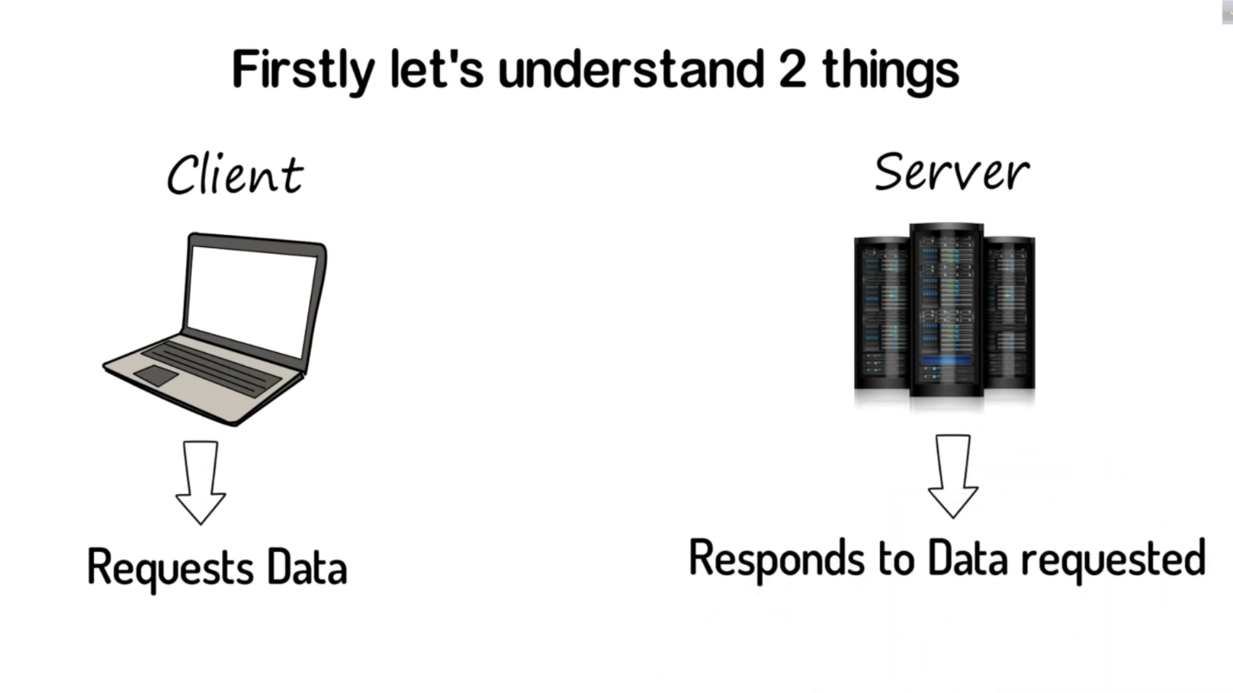

Imagine a phone is a device which request a data to go to google.com and this request go to google’s server and give the client the right page .

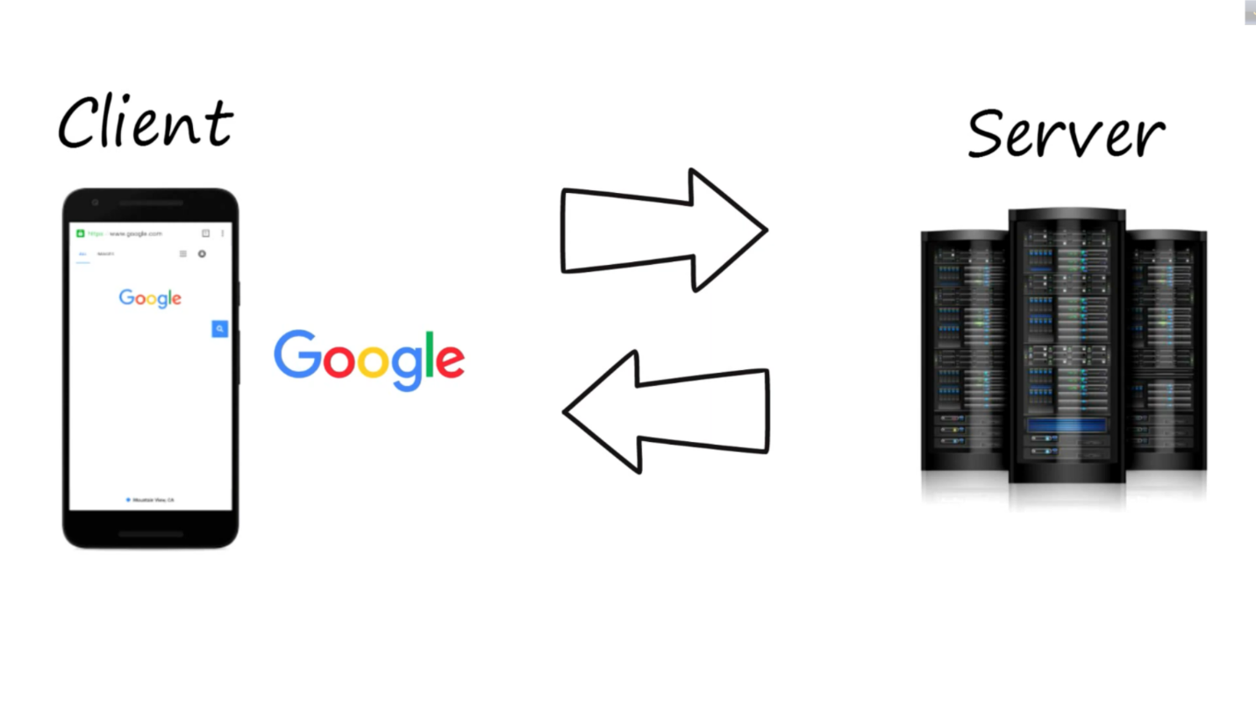

Same method we use in NodeMcu to make it a WebServer.

**NodeMcu as a WebServer:**

1st we do code and then upload it to NodeMcu and when a client request it to off or on the led . NodeMcu will repond to the client.

Code:

|  |  |
| --- | --- |
| |  | | --- | | #include<ESP8266WiFi.h> WiFiClient client; WiFiServer server(80); void setup() {   // put your setup code here, to run once: Serial.begin(9600); WiFi.begin("ICE_Innovation_Lab", "beinnovative#"); while(WiFi.status()!= WL_CONNECTED) {   Serial.print("..");   delay(200); }  Serial.println(); Serial.println("wifi is connected"); Serial.println(WiFi.localIP()); server.begin(); }  void loop() {   // put your main code here, to run repeatedly: client = server.available(); if(client == 1) {   String request = client.readStringUntil('\n');   Serial.println(request); } } | |

After uploading this code into the NodeMcu we will see this page,

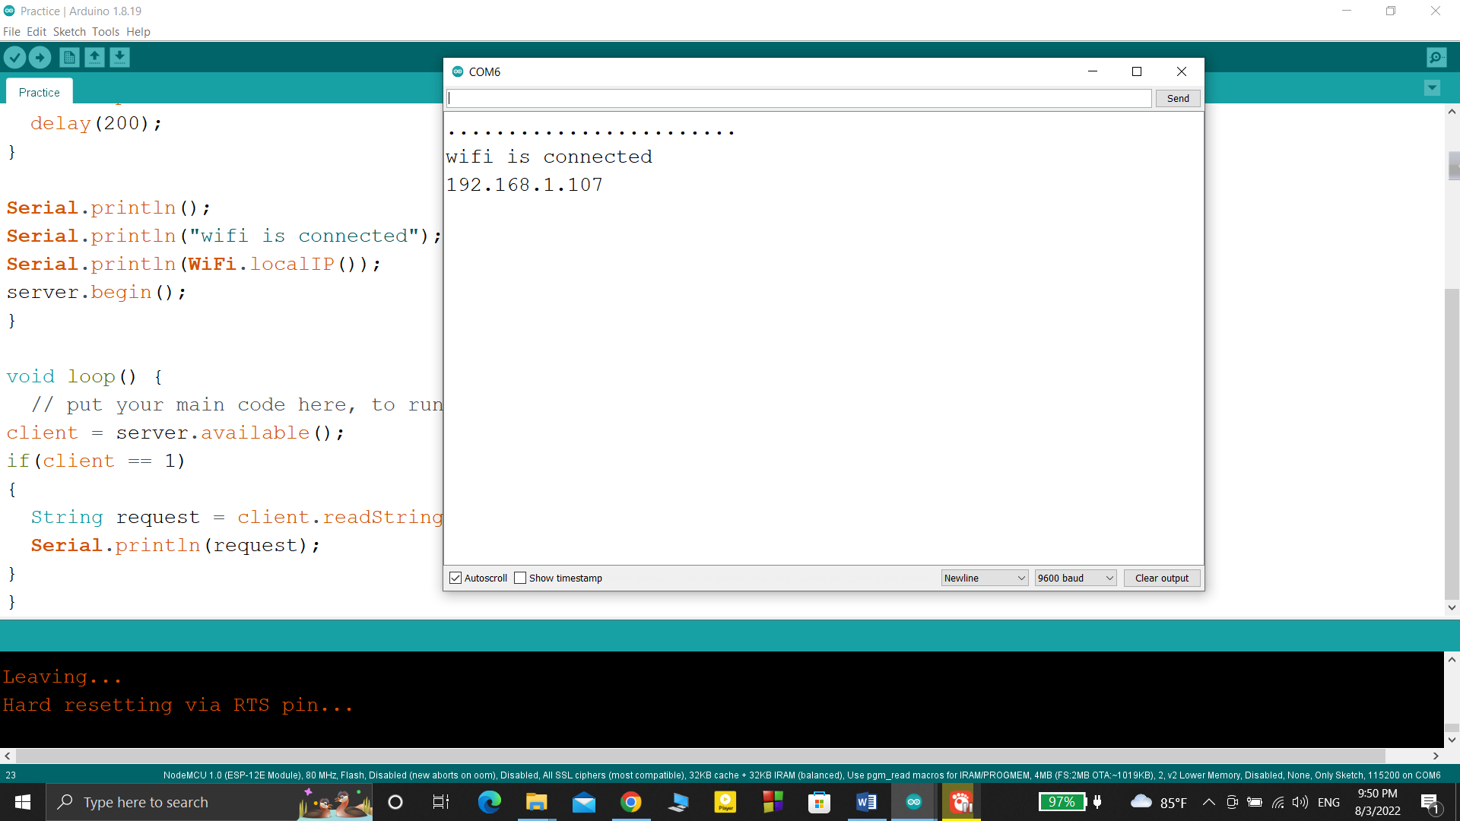

Then we will copy the ip address and then go to browser and paste the ip and then type ip/msg (192.168.1.107/”msg”)

Then enter the button and we see this page ----

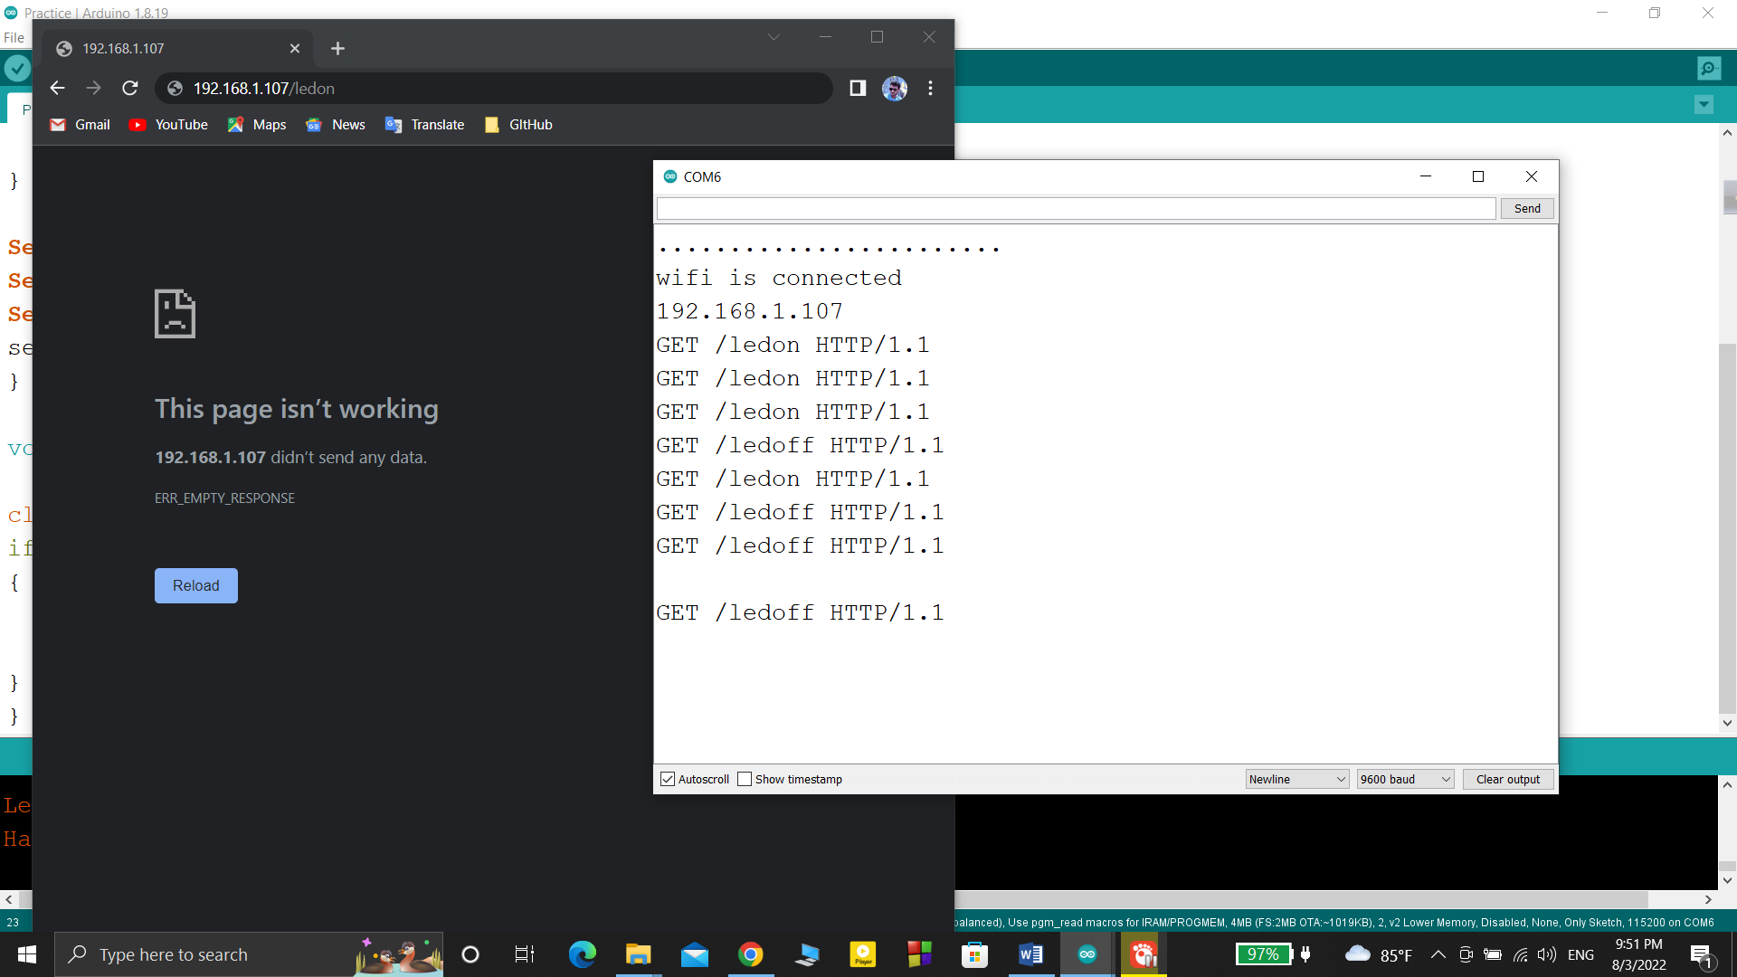

1st work: Turn the led off and on using NodeMcu8266 web server.

Code:

|  |
| --- |
| #include<ESP8266WiFi.h> WiFiClient client; WiFiServer server(80); #define led D7 void setup() {   // put your setup code here, to run once:   Serial.begin(9600);   WiFi.begin("ICE_Innovation_Lab", "beinnovative#");   while (WiFi.status() != WL_CONNECTED)   {     Serial.print("..");     delay(200);   }    Serial.println();   Serial.println("wifi is connected");   Serial.println(WiFi.localIP());   server.begin();    pinMode(led,OUTPUT); }  void loop() {   // put your main code here, to run repeatedly:   client = server.available();   if (client == 1)   {     String request = client.readStringUntil('\n');     Serial.println(request);     request.trim();      if (request == "GET /ledon HTTP/1.1")     {       digitalWrite(led,HIGH);     }      if (request == "GET /ledoff HTTP/1.1")     {       digitalWrite(led,LOW);     }   } } |

After that , when we do this things on browser the led light is in control

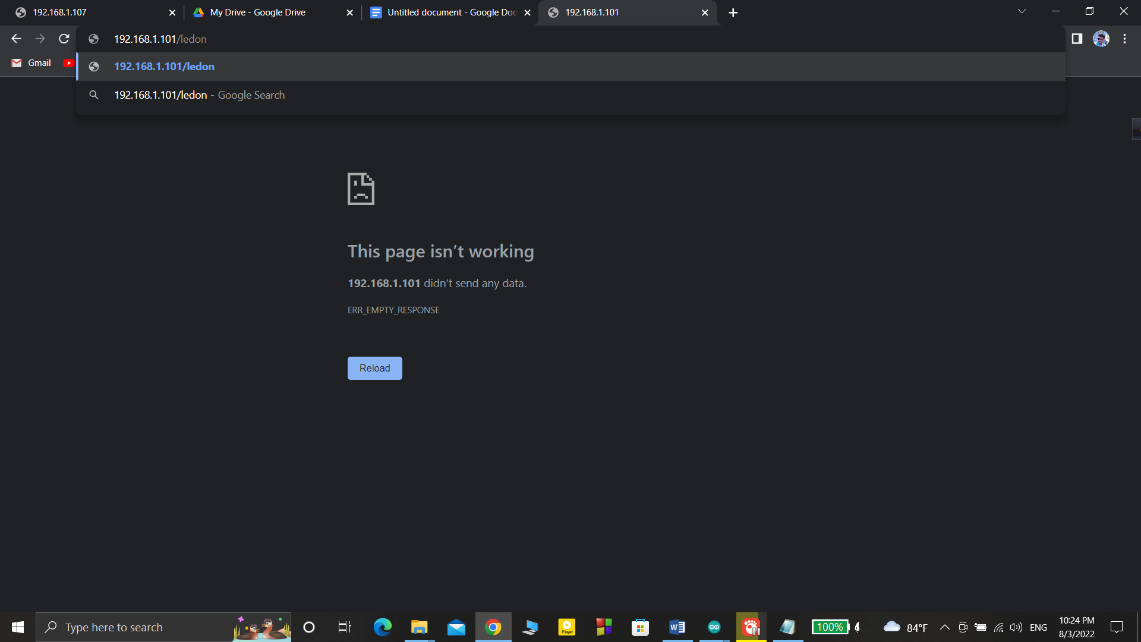

Then the led light turns on .

And

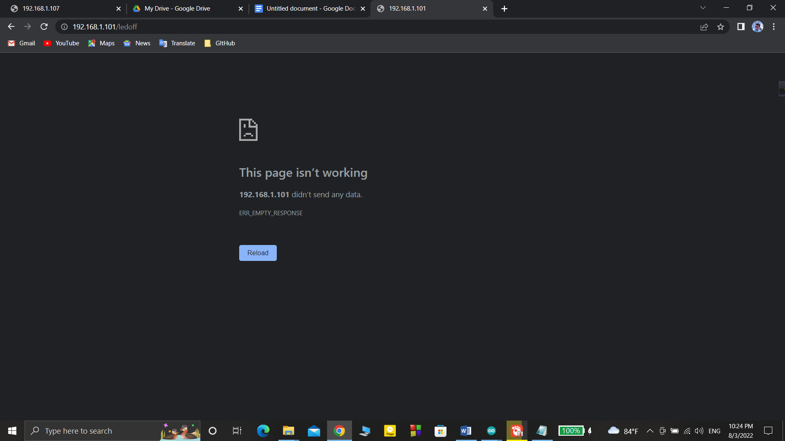

After pressing enter the led light turns off.